Assignment No 4:
Creted docker with Jenkins file in multipale branch and along with that attached docker volume
- Github repo- where 3 branch created and inside that index.html are present with Jenkins file, where all scripting I have wrote.

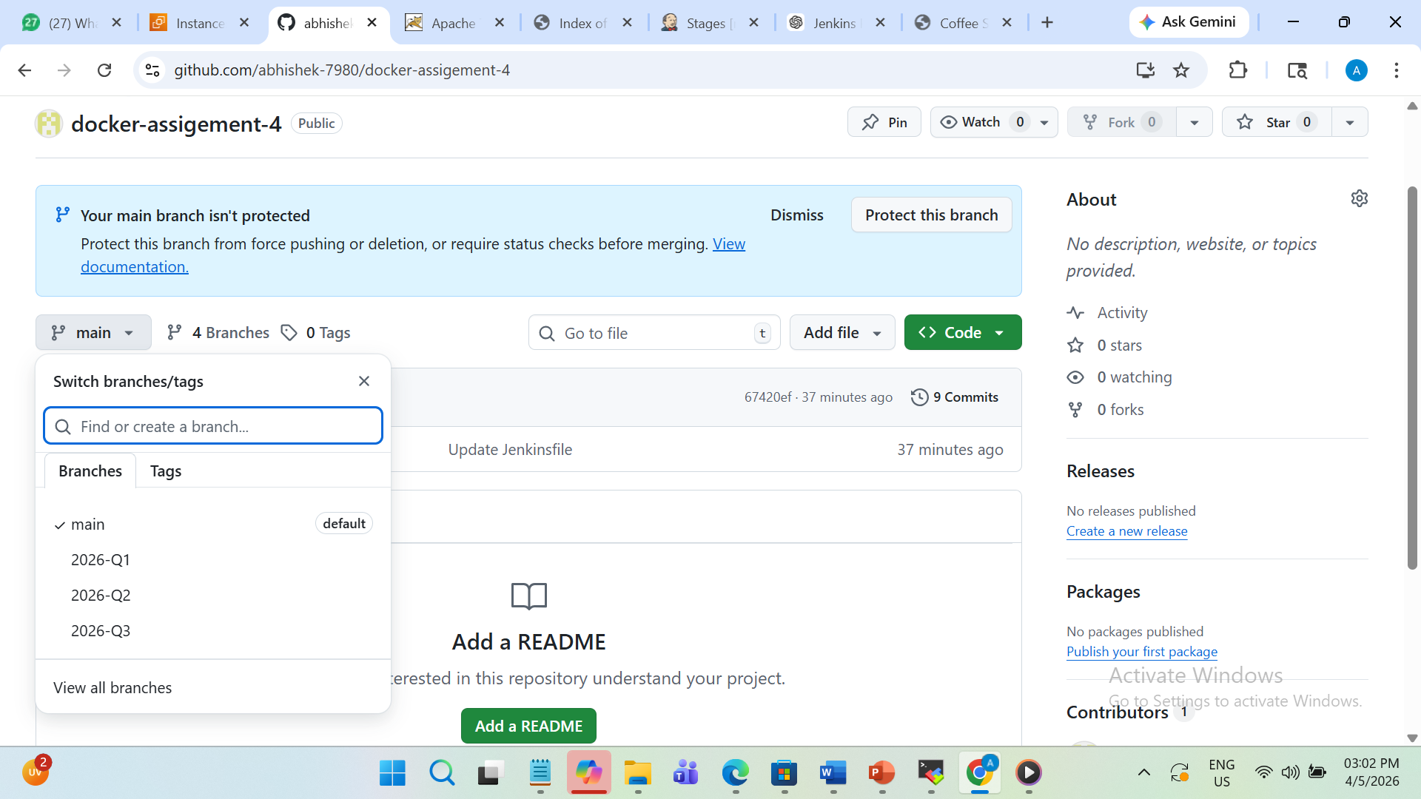
- This is my Jenkins file script
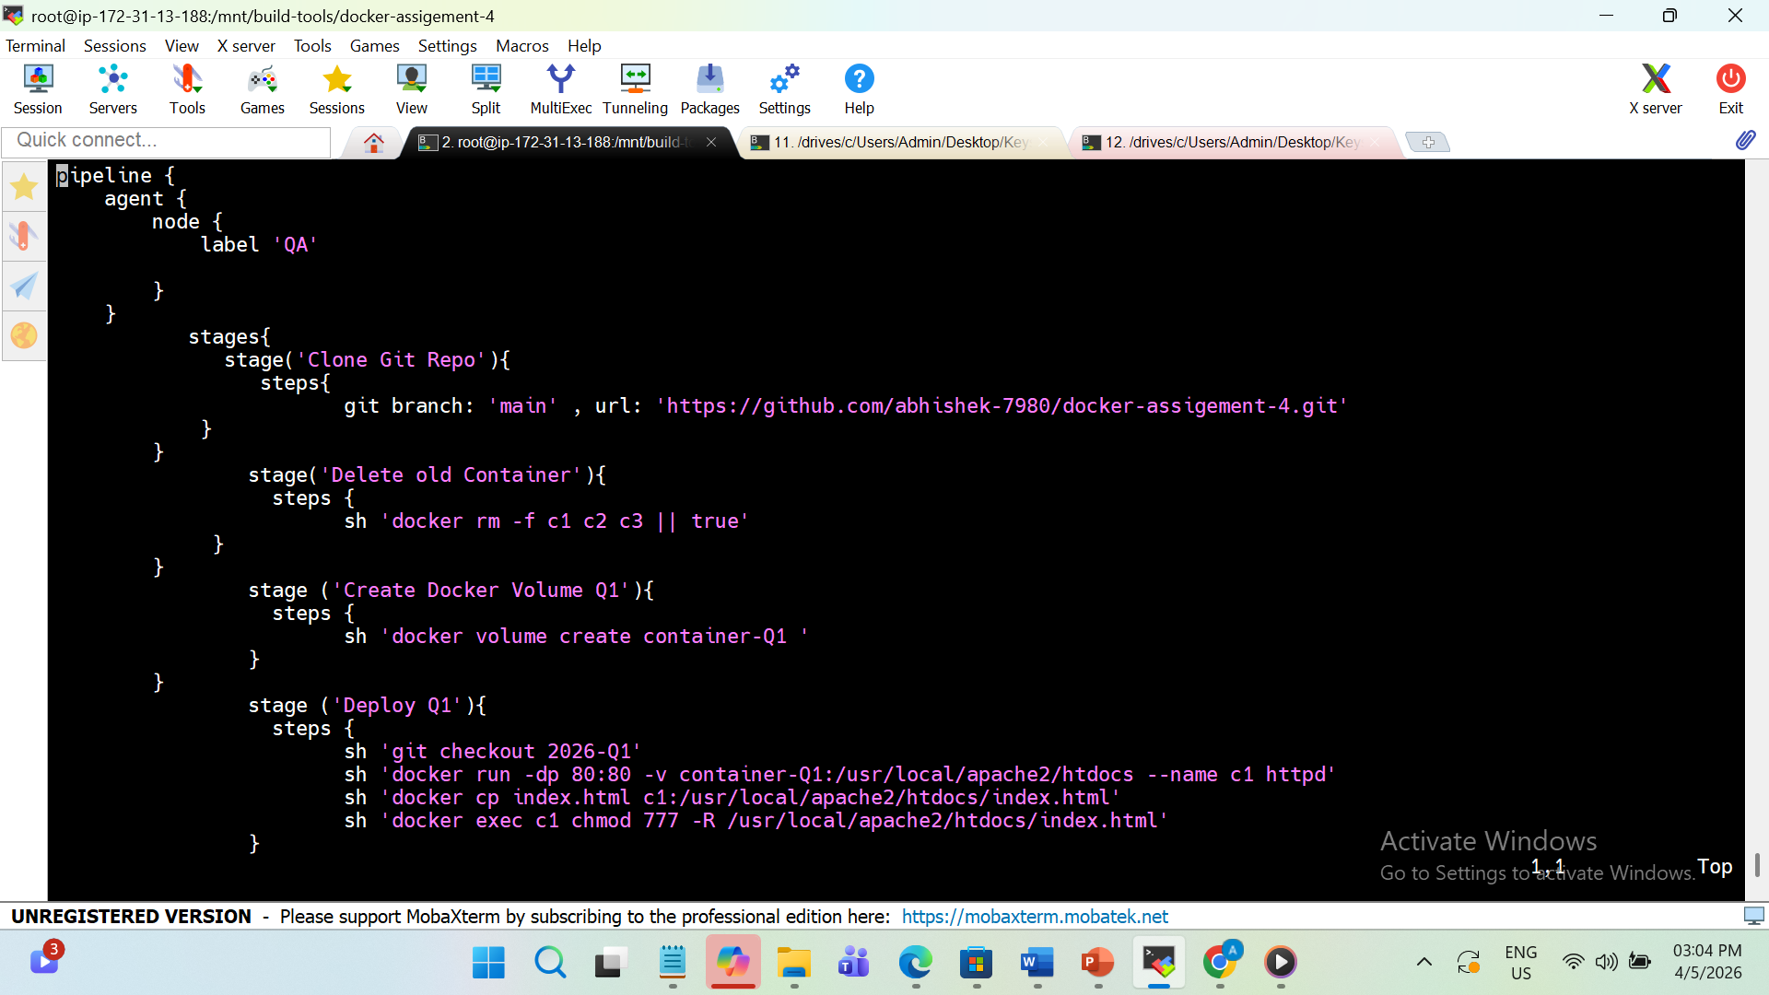

- Here I have succesfully build my project
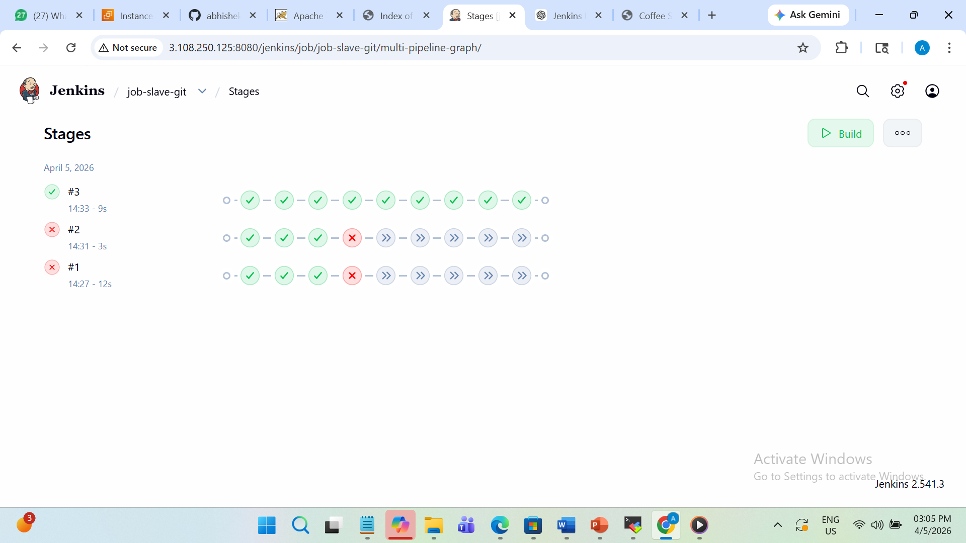

- Here you can verify that volumes are crated through jenkinsfile script using JM JOB
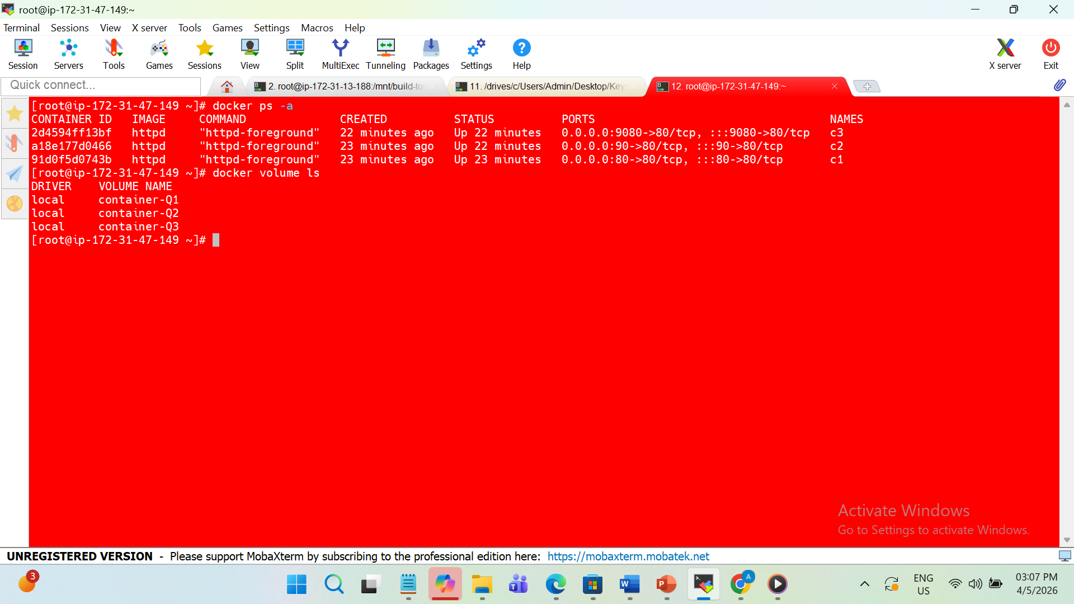

- Her I am doing configuration to execute my job as SCM-git and github repo
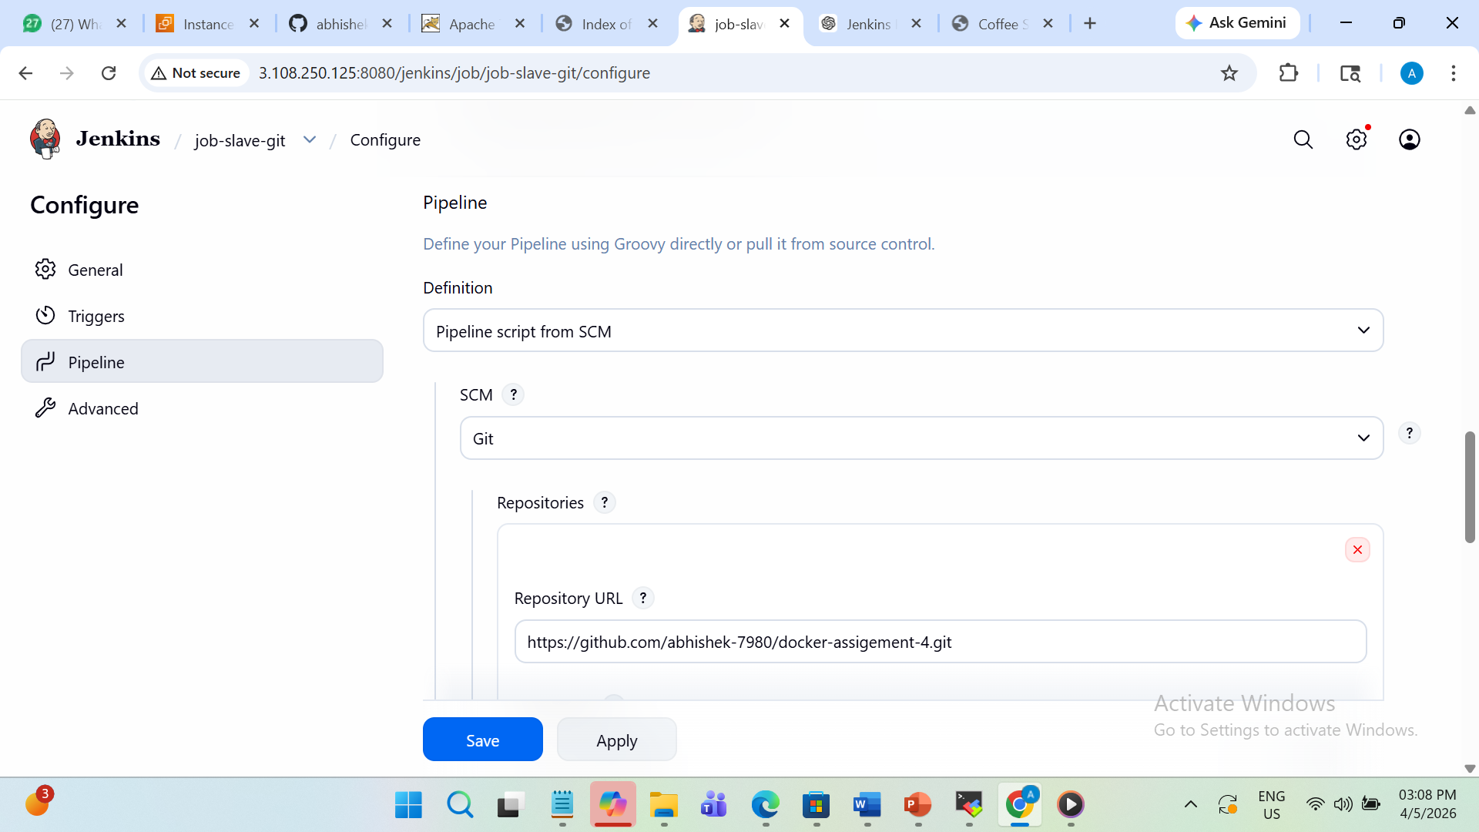

- Here if u can see I have updated my jenkinsfile and commit and push changes

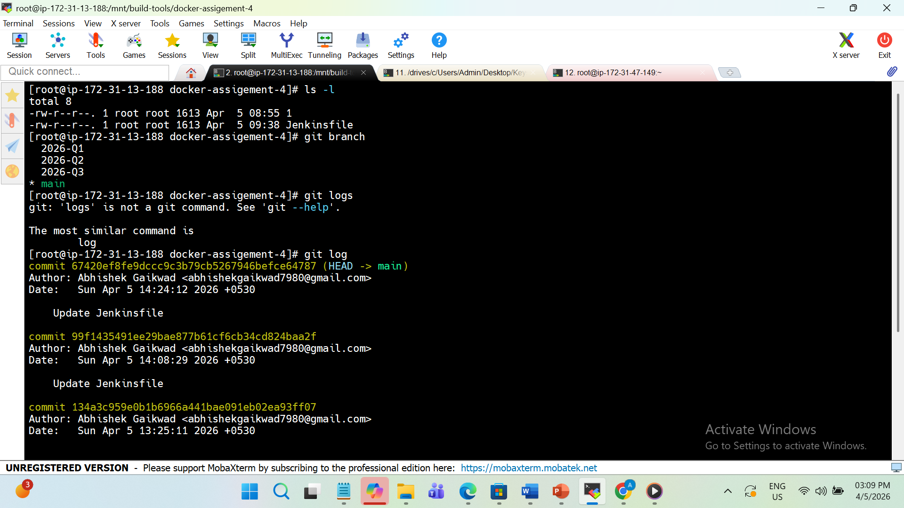
- This is and 2026-Q1 output of index.html file at port 80
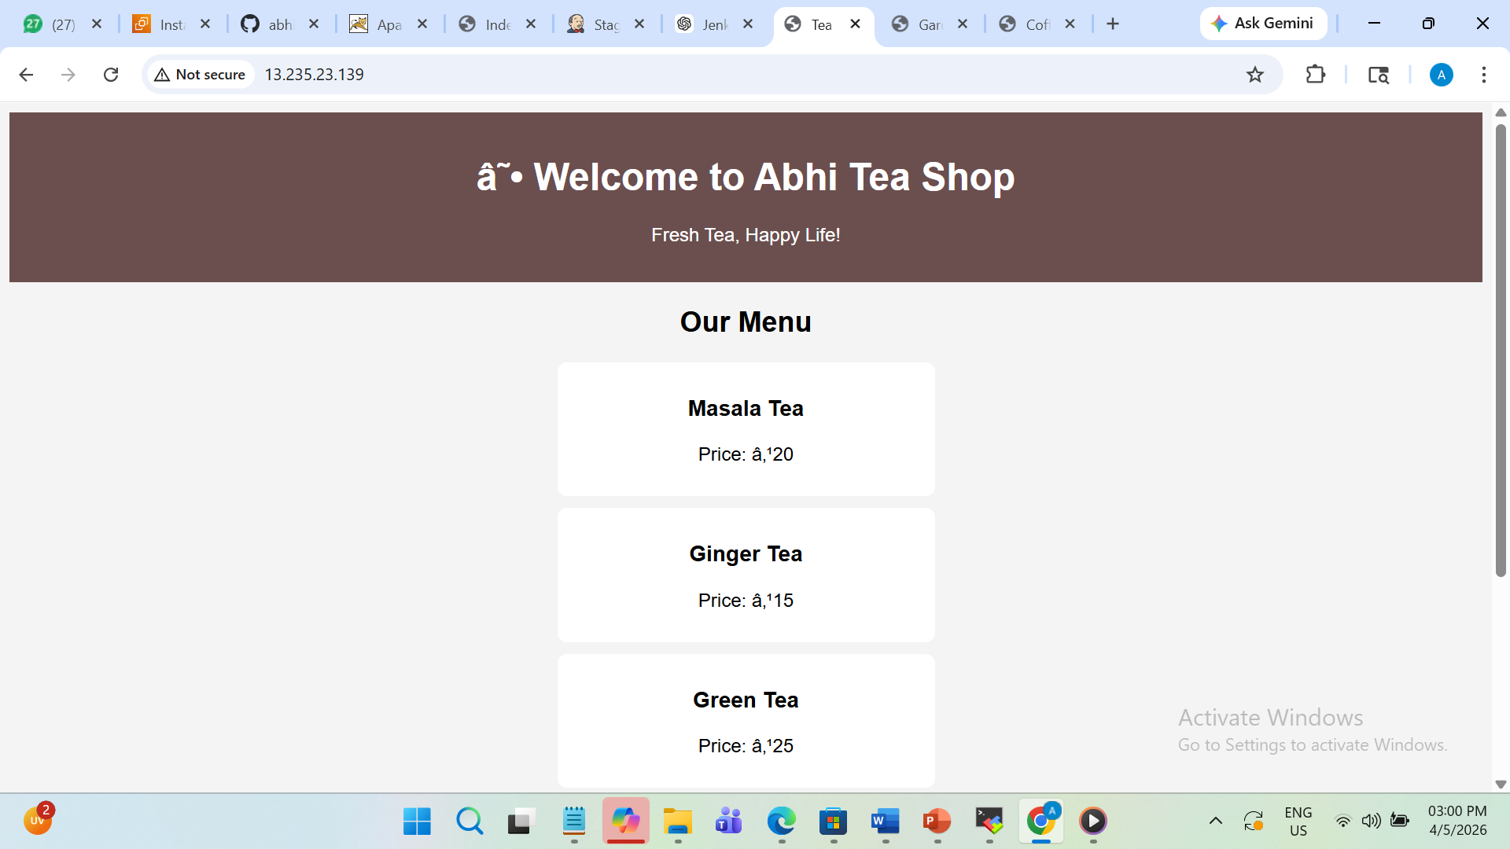
- This is and 2026-Q2 output of index.html file at port 90
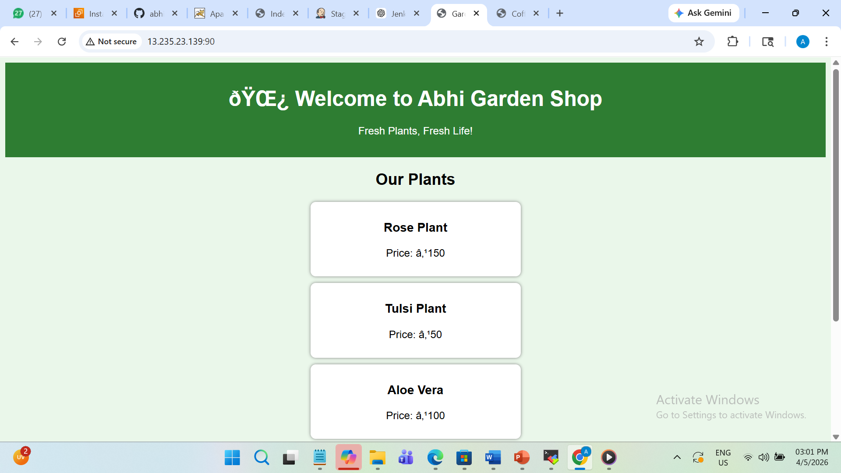

- This is and 2026-Q3 output of index.html file at port 9080

